**REDCap OMR Technical Guide**

**Introduction**

This project is used in tandem with REDCap to turn REDCap surveys into paper surveys so that they can be printed, distributed, and analyzed in cases where research participants have no access to the internet. In particular, this project was created for the Research Participant Perception Survey program, which aims to study and improve the ways that research studies are carried out. The RPPS administration’s goal is to improve research experiences for distributors and their studies’ participants.

This application aims to help fulfill the RPPS’s goal by streamlining the process in which paper surveys can be sent to populations (like the elderly and those with lower income) that have either no or little access to the internet. Instead of manually printing out each survey and dedicating individuals to fill the received answers into REDCap by hand, you can instead use REDCap OMR’s streamlined steps to automatically create surveys you want converted to paper, analyze the answers on these forms once filled out, and upload their results back to REDCap for each record desired.

**Installation**

# **Windows**

## Getting Started

To start using the REDCap OMR application, there are a couple of things we need to ensure are downloaded:

* WSL 2 (downloaded in Powershell)
* [Docker Desktop](https://www.docker.com/products/docker-desktop)

Installing both of these tools is relatively easy, however. To start, you first need to download WSL on the Windows machine that will be running the REDCap OMR app. Before doing this, there are a few things that need to be checked first. First, you must have **Windows 10 (Build 19041 and higher)** or **Windows 11**. You can check your version of Windows by doing the following:

* Click on the search bar and type **“about”** to find the **“About your PC”** page.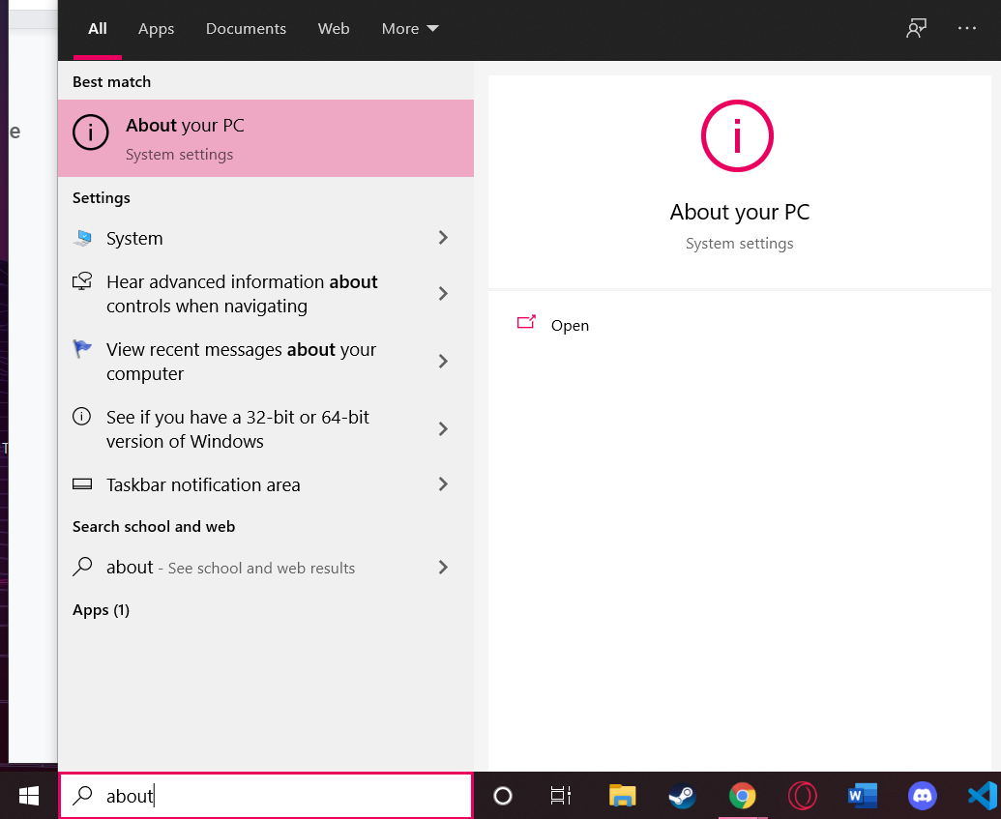
* From there, find the **“Windows specifications”** section. Your Build number will be listed as **“OS build”** under this section.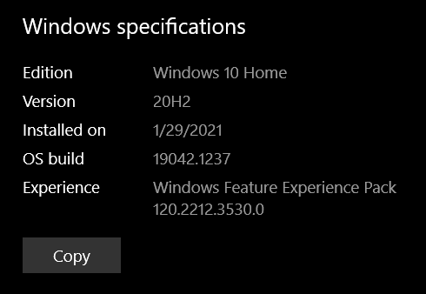
* If your build number is lower than the specified version 19041, please update your Windows PC to its latest version to continue this tutorial.
* Along with a valid build version, virtualizationalso needs to be enabled on the system. To check for this, open your Task Manager (**Ctrl + Alt + Delete > Task Manager OR type “task manager” in the search bar**).
* Inside Task Manager, open up the **“Performance”** tab and look for **Virtualization**. If this is listed as enabled, then you’re all set to install WSL 2! If it’s not listed, then please visit [this link from Docker](https://docs.docker.com/desktop/windows/troubleshoot/#virtualization-must-be-enabled) for more information.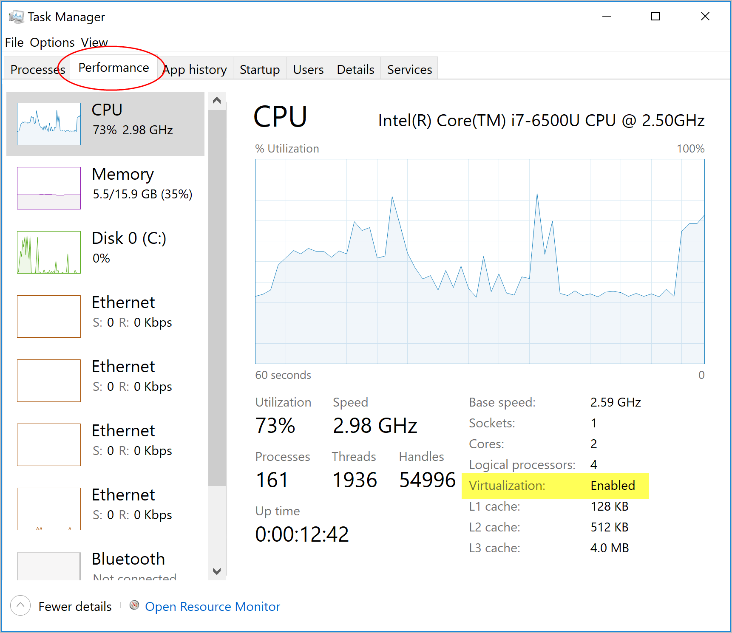

## Installing WSL 2

WSL (or Windows Subsystem for Linux) is a backend system for Windows that allows users to run programs that use the Linux environment natively, and it is required to get Docker to run properly. With a valid Windows version and Virtualization enabled, you’re now ready to install WSL 2.

* To start, first type in **“powershell”** in the search bar and click on the **“Run as administrator”** button next to the **Windows Powershell** app.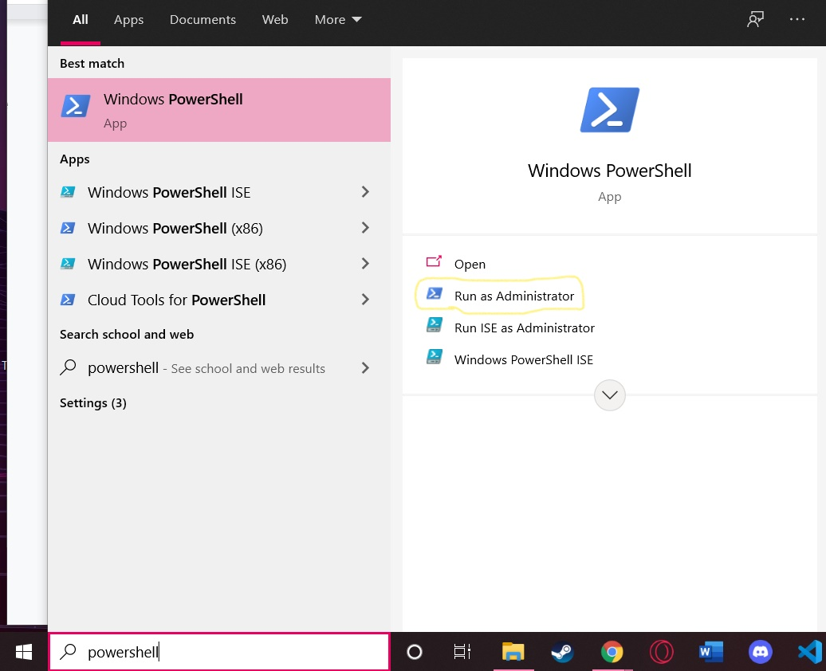
* Your Powershell instance should look like this: 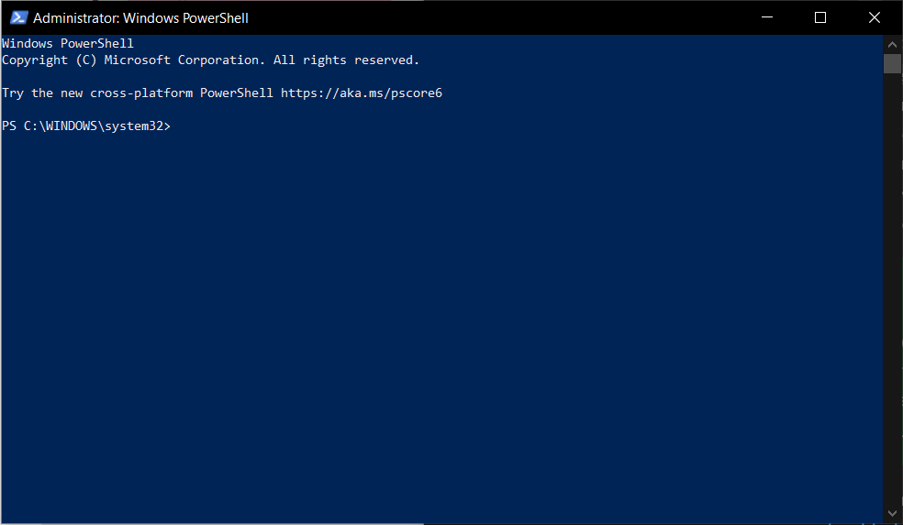
* Once you’re in the Powershell, type wsl --install on the prompt, then hit **Enter**. The installation may take about 5 minutes.
* When that’s done, WSL 2 should be fully installed on your system, so all you have to do now is restart your PC to fully enable it.

### Troubleshooting

* If you’ve gotten to this point and the past steps didn’t work, there are still more ways to download WSL 2 onto your Windows system. The first two things to do are to go to [this installation link in the Windows documentation](https://docs.microsoft.com/en-us/windows/wsl/install#install) and follow the steps it has there. If nothing in that guide helps, then you can manually install WSL 2 by following [this manual installation guide by Microsoft](https://docs.microsoft.com/en-us/windows/wsl/install-manual).

## Installing Docker Desktop

* Now that you have installed WSL 2 and restarted your PC, you’re now ready to install Docker Desktop. Docker Desktop is a tool for Windows that simplifies the process of using Docker and starting/stopping Docker containers and images. To install it, you need to head to Docker’s [Docker Desktop Windows Installation Guide](https://docs.docker.com/desktop/windows/install/) and click on the download button under the **“Download Docker Desktop for Windows”** section.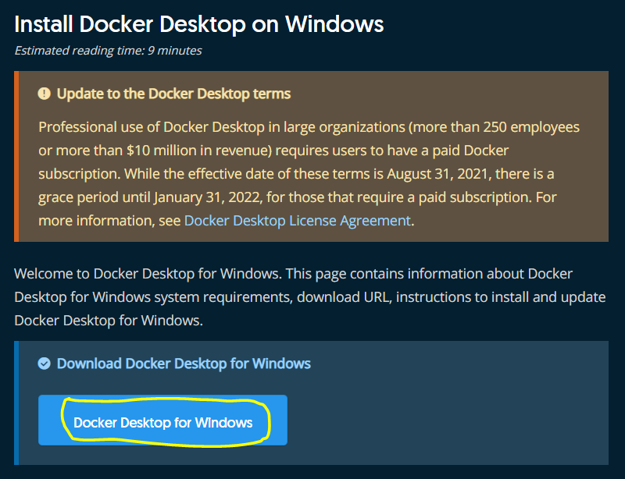
* Once the download is done, click on the **installer** (**Docker Desktop Installer.exe**) and open it. If you’re unable to open it from your web browser, open the **File Explorer** on your desktop and navigate to the **Downloads** folder. Double click on **Docker Desktop Installer.exe**, and follow the installation instructions.
* You should have to make no changes to the defaults of the installation, so proceed without changing anything. Once it’s installed, you’re all good to go with Docker Desktop.

## 

## Downloading REDCap OMR from GitHub

* For the next step in the installation, you need to download the REDCap OMR project from Github. To do this, we need to download the **ZIP file** of the repository from the **GitHub page**.
* To download the REDCap OMR project from Github, please visit [this repository link](https://github.com/cojohnson1999/REDCapOMR). Once you get to the site, click on the **“Code”** dropdown and then select **“Download ZIP”**:

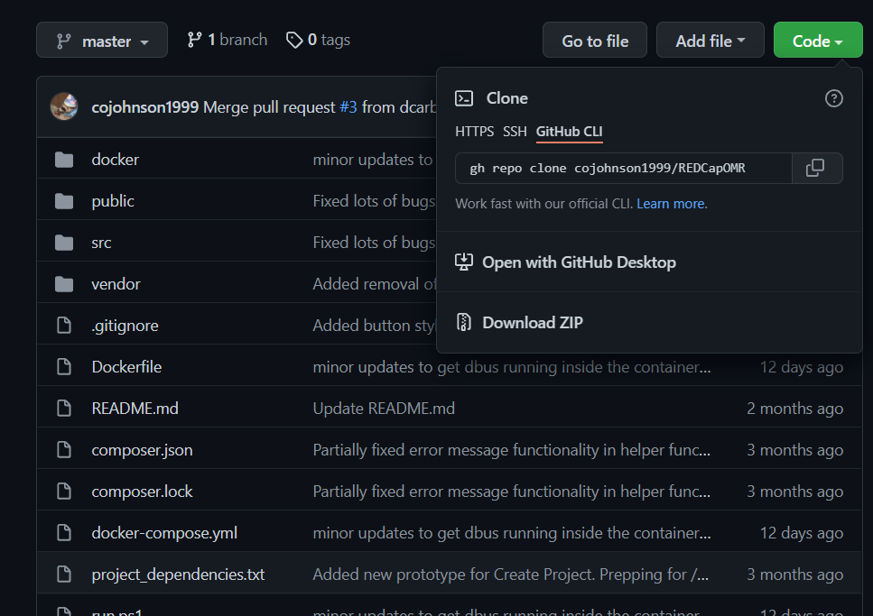

* The ZIP file of the project will now be downloaded to your **Downloads** folder. Once that’s done, find a convenient folder to house the project (I recommend **Documents**). Move the ZIP file to this location, then unzip the folder ([Microsoft Tutorial on Unzipping](https://support.microsoft.com/en-us/windows/zip-and-unzip-files-f6dde0a7-0fec-8294-e1d3-703ed85e7ebc)).

## Creating the Docker Container

* Note: Before doing this step, please **ensure that Docker Desktop is running on your machine**. It gives you admin privileges and allows regular users to work with Docker. Without it, you’ll get an error when trying to build and run the container.
* In the unzipped “REDCapOMR” folder, double click **run.bat**. This **creates and runs your Docker container**! This step can take several minutes both on the first run and on subsequent runs if there are updates. your server will be up and running when you see something similar to this:
* If you see something similar to this (specifically the “apache2 -D FOREGROUND” line at the end), then your REDCap OMR web application is ready to be used!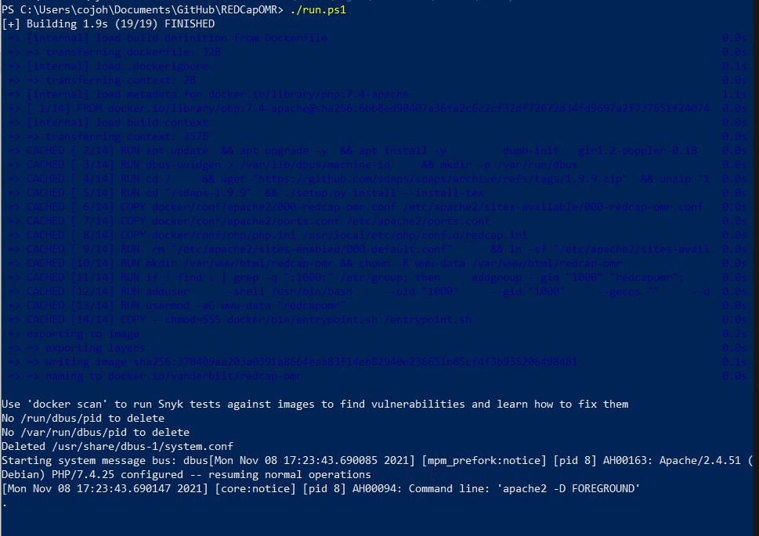

# **Mac**

# 

## Getting Started

To start using the REDCap OMR application, there are a couple of things we need to do:

* Check if your Mac has an Intel processor or Apple Silicon chip
* Download Docker Desktop for Mac

Both of these steps are relatively easy, but both are necessary to get Docker to function properly on your Mac machine. It is worth noting that checking the processor is **very** important for Docker installation. The processor/chip difference between Intel and Apple Silicon entirely changes the installation method for Docker, so it’s very important to find this information **before** attempting any installation.

## Checking Processor/Chip Type

* Checking your Mac system’s processor/chip type is a relatively easy process on Mac. To do so, follow the following steps:

1. Head to the menu bar and click the **Apple logo**.
2. Click **“About This Mac”**.
3. Mac computers with Intel processors will show an item labeled **“Processor”**, while Mac computers with Apple silicon will show an item labeled **“Chip”**.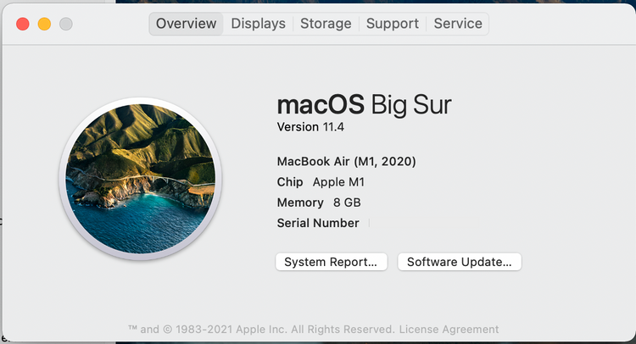

* This information was pulled from [this guide by makeuseof.com](https://www.makeuseof.com/how-to-find-out-if-your-mac-uses-intel-or-apple-silicon/).

## Installing Docker Desktop

Next, we need to install Docker Desktop to ensure that your machine will be able to run the REDCap OMR application. Docker’s website has a great guide that details installing the application on Mac machines that have Intel processors or Apple silicon chips.

* Go through [this guide](https://docs.docker.com/desktop/mac/install/) to install Docker/Docker Desktop
* Open Docker Desktop
* Enable permissions by entering your system password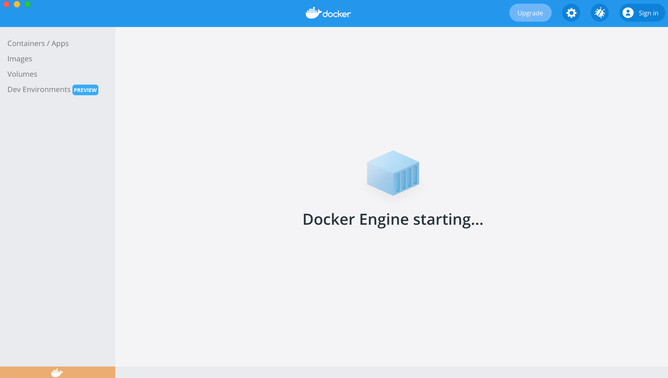

### Troubleshooting

* If you’re having problems getting Docker Desktop installed on your Mac machine, first double check that you’re following instructions for the proper processor/chip for your machine.
* After that, give [this help guide from Docker](https://docs.docker.com/desktop/mac/troubleshoot/) a visit. Most installation problems should have a solution on this page.

## Downloading REDCap OMR from GitHub

* For the next step in the installation, you need to download the REDCap OMR project from Github. To do this, we need to download the **ZIP file** of the repository from the **GitHub page**.
* To download the REDCap OMR project from Github, please visit [this repository link](https://github.com/cojohnson1999/REDCapOMR). Once you get to the site, click on the **“Code”** dropdown and then select **“Download ZIP”**:



* The ZIP file of the project will now be downloaded to your **Downloads** folder. Once that’s done, find a convenient folder to house the project (I recommend **your user directory**). Move the ZIP file to this location, then unzip the folder by **double-clicking it** ([Apple Tutorial on Unzipping](https://support.apple.com/guide/mac-help/zip-and-unzip-files-and-folders-on-mac-mchlp2528/mac)).

## 

## Creating the Docker Container

* Now that the folder we downloaded from Github is unpacked, we need to access the folder’s directory so that we can build and run REDCap OMR’s Docker container!
* To do this, first open a terminal window by doing one of the following:
  + Click the **Launchpad** icon  in the Dock, type Terminal in the search field, then click Terminal.
  + In the **Finder** , open the /Applications/Utilities folder, then double-click Terminal.
* After you have the terminal open, the next step is to find and move the terminal to the REDCap OMR **project folder** that you downloaded.
  + One way to do this is to use the **cd [path/name]** command to **change directories**. If your terminal starts in the home directory by default, your **cd** command would look like **“cd Users/[myusername]/REDCapOMR”**.
* Once you’re in REDCap OMR’s directory, you need to execute the **run.sh** file, which will **build and run** your Docker container. To do this, do the following command:

sh run.sh

* This command may fail due to access permissions. If it does, there are **two commands** you can try to fix this:

sudo sh run.sh **or** chmod 755 run.sh then sh run.sh or sudo sh run.sh

* If it worked, you should see a long list of files being downloaded and commands being executed. If that happens, let Docker prepare the container and wait. After the REDCap OMR application is ready to be used, one of the last lines should reference **apache**, which is the service that hosts the container on your web browser!
* Once that’s done, type **localhost:8080** into the search bar of your browser. If you see this screen, you’re ready to use the application!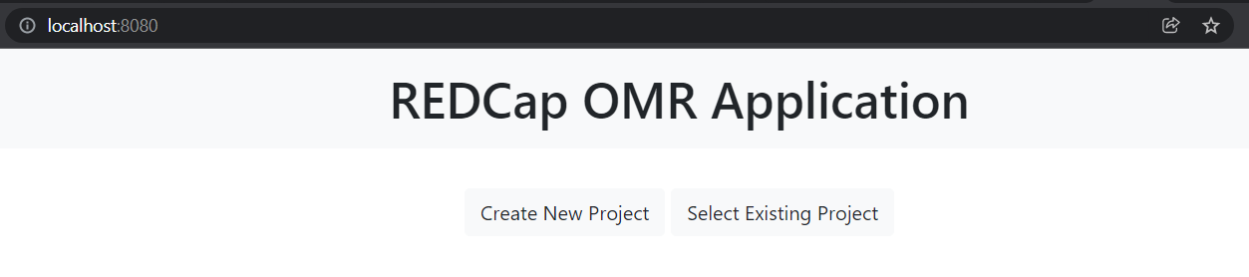

# **Linux**

# 

* Coming soon!

**Using the REDCap OMR Application**

* **(Windows)**: Please make sure you’ve started Docker Hub before attempting to open **run.bat**.
* Now that we’ve made it this far, we need to actually get into the application! To do this, make sure that your server is still running from **run.bat** or the **run.sh** command you entered earlier. If it isn’t, enter the command again to rebuild and restart the server.
* Once you’ve done that, open a web browser of your choosing, and type **localhost:8080** in the search bar!
* This will lead you to the application, so now we can get started with a tour of the functionality of the app.

## The App Workflow

* Application workflow is very important for understanding the usage of REDCap OMR.
* The tasks in the application are divided among different stages. The process of using the app is as follows:

### The Preparation Stage

#### The Login Page

* + - 1. Create your REDCap OMR project in the login page under the **“Create New Project”** tab. Enter the API URL of your REDCap project (for example, this is <https://redcap.vanderbilt.edu/api/> for Vanderbilt) and then your project’s API token.

API tokens can be generated in 3 different ways, depending on if you currently haveAPI privileges:

* If you **already have an API token** **and API privileges**, go to the **API** option under **Applications** in REDCap, and then click and copy the API token displayed.
* **If you don’t have an API token but have API privileges**, go to the **API** option under **Applications** in REDCap, and select **Generate Token**.
* **If you don’t have API privileges,** check to see firstly if you have access to the **User Rights** option under **Applications**. It will look like this: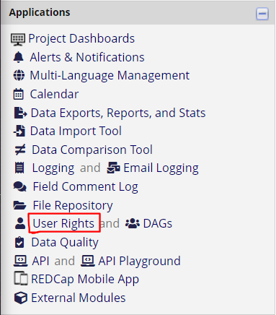

If you don’t see this option, then **contact your REDCap project’s manager** and **request API access** from them.

If you do see this option, then click on it and **click on your REDCap username** then **“Edit user privileges”** in the table of project users, located on the page: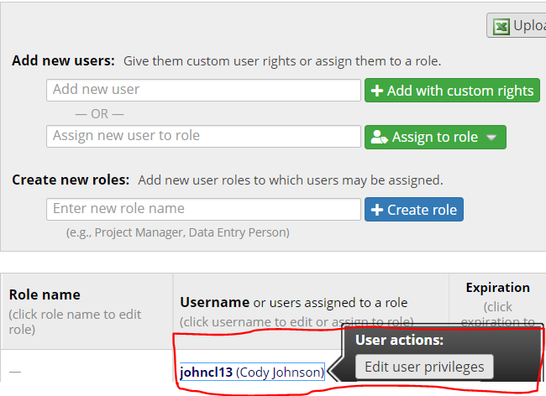

After doing this, check the **API Export** and **API Import/Update** options under the **“Other privileges”** group:

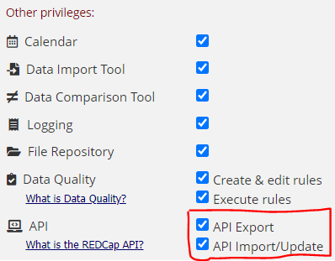

Click **Save Changes**, then go to the **API** option under **Applications** in REDCap, and select **Generate Token**.

After these are entered, the app will prompt you to select the instrument you want to use to create your REDCap OMR project. Select it, then press the **“Create Project”** button. After project creation is finished, you will automatically be carried to the next page.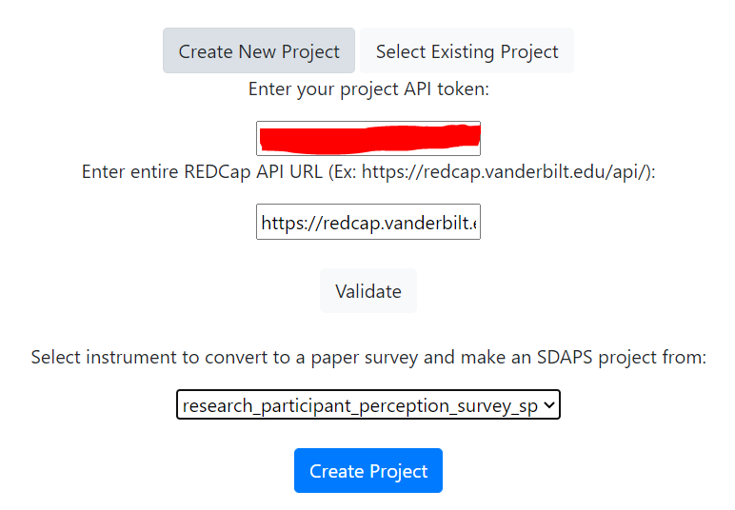

If you instead want to use a project you previously created, select it from the **“Select Existing Project”** tab.

You will see a list of projects already created in REDCap OMR. This will show the name of your project in REDCap and its Project ID. 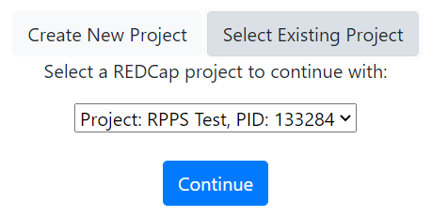

**All** instruments inside that REDCap project are accessible in **one** REDCap OMR project, so the instrument you selected when creating your first project will be accessible in the options available. Select the one you want, then press the **“Continue”** button.

#### The “Create Printouts” Page

* + - 1. After this, you will be taken to the **“Create Printouts”** page. From there, select the project for the specific **REDCap form** you’re working with and the **ID field** for your REDCap form.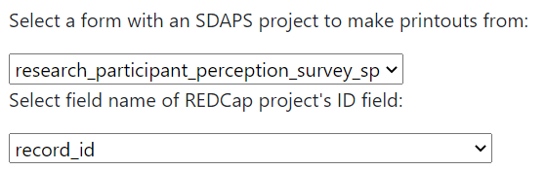

Ex:

* + - 1. After you enter both of these, click the **“Get Records”** button. This returns a checkbox list of **REDCap records** that you want to make printouts of.
      2. After the records are selected, press the **“Create Printouts”** button and wait for the application to finish creating the printouts. Once these are done, save the file created below the **“Create Printouts”** button.

**Note**: This file contains a REDCap survey for every REDCap record you selected in the checkbox list. You can tell which form is assigned to which record by looking at the **header on each page of the printout**. It always specifies the **REDCap survey record number** it corresponds to.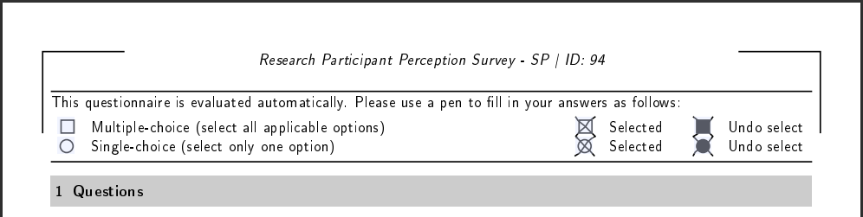

Ex:

### The Distribution Stage

* The Distribution stage of the app doesn’t involve the app itself whatsoever. This stage of the application workflow is simply distributing the survey printouts (from the **“Create Printouts”** page) to the respective survey participants who need to fill them out.
* You can continue to the next stage after either one or all of the filled-out surveys are returned to the survey site.
* **Note**: I recommend waiting until all surveys are returned to scan them in, so that you can scan all your results into one big PDF. However, note that the max file size allowed to be uploaded is set to **32 megabytes by default**.

This can be changed by increasing the values of **upload_max_filesize** and **post_max_size** in **REDCapOMR/docker/conf/php/php.ini,** and then rebuilding the container by running **./run.bat** again.

### The Result Collection and Export Stage

#### The “Upload Scans” Page

1. After scanning in your results on your local system, the next step is to upload them to your REDCap OMR project through the **“Upload Scans”** page. To do this, first go to the page and select the **REDCap form** you want these to be associated with in your project.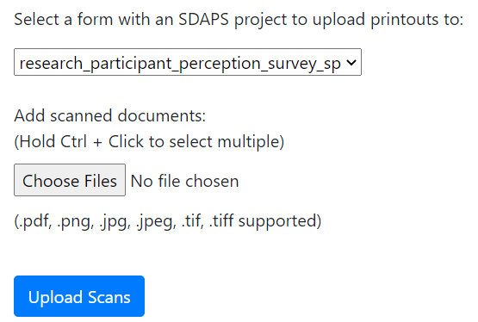
2. Next, click the **“Choose Files”** button. This will open up a File Explorer window to choose files from. From here, select **all the files** that you want to be scanned by REDCap OMR, then select **“Open”**.

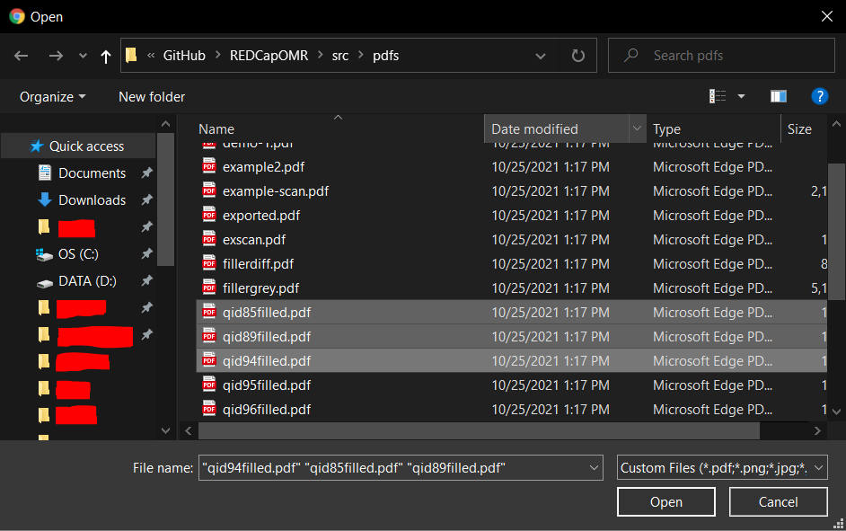

**Note**: To select multiple files, click on the first one you want to upload, then **hold Ctrl (or Cmd on Mac) and click on all the others** you want included.

1. The application should now show you the number of files you selected to be uploaded like this: 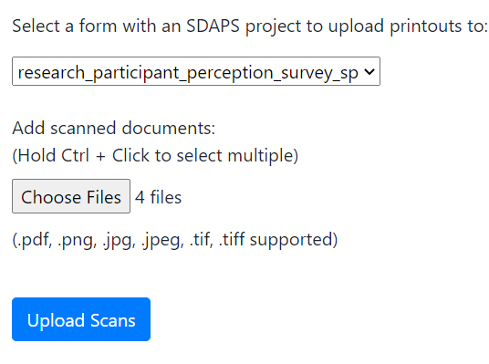
2. Once you have selected all the files you want uploaded, just click the **“Upload Scans”** button, and they will be added to the directory holding all the scanned documents of your project (found in **REDCapOMR/public/tmp/[project_id]/[instrument_name]/uploads**).

#### The “Run Recognition” Page

1. Now that you have uploaded all your files, all you have to do on the **“Run Recognition”** page is select the project whose scanned surveys you want analyzed, then click the **“Run Recognition”** button.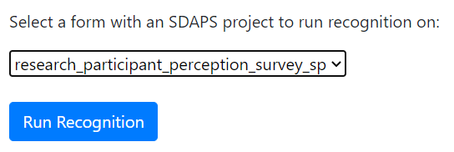

**Note**: Depending on the length of your survey and the amount of files you uploaded to the REDCap OMR project, this step could take a while. Remember to be patient!

#### The “Export Results” Page

1. And now for our last step of the Collection and Export stage, we need to export the scanned results **back to the REDCap project itself**! To do this, first go to the **“Export Results”** page and select the project you’ve been working with so far.
2. Now, a table with information about the scanned surveys will pop up on your screen. After verifying that the data is okay to send, simply click the **“Export Results to REDCap”** button, then your scanned form data should appear in REDCap.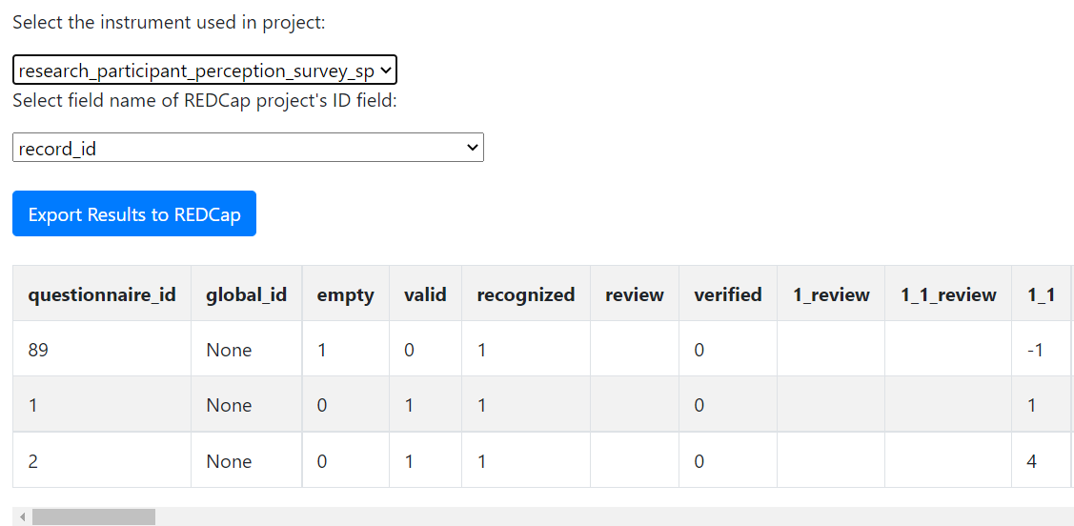

To verify this, go to **Add / Edit Records** under **Data Collection** in REDCap, then choose one of the records you sent out and scanned back in to verify that REDCap OMR successfully scanned the data. If data was scanned in successfully, the record should display a **yellow** icon, meaning the record is filled in but unverified (like this):

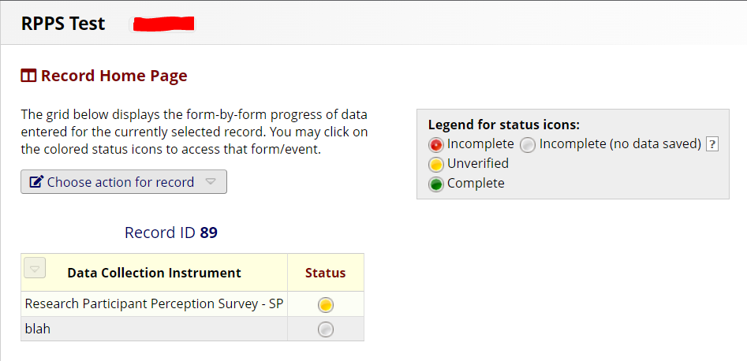

* And now you’re finally all done with the workflow of the project! Now all that’s left to go over are the extra pages that give the app some additional functionality for users.

### Extra Pages and Functionality

#### The “View Printouts” Page

* The **“View Printouts”** page lets you view all the printouts you create in your project. This step is useful if you forget to download one of the created printouts in the **“Create Printouts”** page.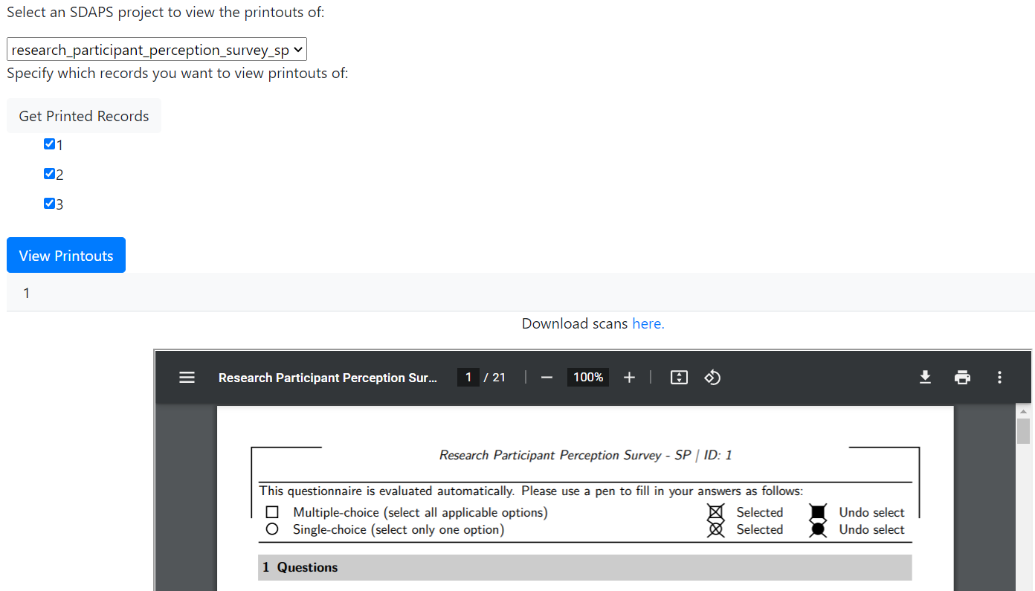

**Note**: However, the page will not split the PDFs between the different survey IDs. If you create a PDF in **“Create Printouts”**, the first record ID to be tied to that printout PDF will be the only option of the record IDs you selected that is displayed on the resulting menu.

#### The “Settings” Page

* The **“Settings”** page gives you three main points of functionality within the app:
  + Changing your project’s API key/token and the URL
    - This option is especially useful if you have to generate a **new API key/token** for your project on REDCap for whatever reason. If that happens, just go to this page and enter the new one.
  + Resetting your project
    - This option removes **all** files uploaded to the project, **all** printouts created for it, and **all** data scanned for the project. It will verify that you really want to reset your project before it resets it.
  + Deleting your project
    - This option simply deletes your project in the REDCap OMR file system and all data associated with it. It will verify that you really want to delete your project before it is completely deleted.

#### Select Project

* The **“Select Project”** page just takes you back to the login page you see when you go to localhost:8080 and create your first project.
* You can use it to select a project you were working with previously or create a new one.

# 

**Find a Bug? Have a Feature Request?**

* Find a bug or an issue? Report them on the GitHub repository’s **“Issues”** page or email someone (list emails?). Please give detailed accounts of how to reproduce the bug, and please take the time to give any errors or screenshots when possible.
* Have a feature request? Want something changed? Add to the **“Issues”** list on the GitHub repository, and preface the title of your issue with **“[Feature Request]”** or email one of the emails provided above, and we’ll look into implementing your feature when possible.